**Unit4 B Let’s learn（练习）**

一. 看图写词组

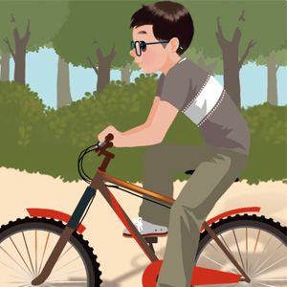1. 2. 3.

___________________ _________________ _________________

4. 5.

 

___________________ _________________

二．补充句子。

1. She _______play ping pong before. Now she can play it well.

1. Wu Yifan didn’t like ______(冬天) before. Now he like it.
2. I love to __________（滑冰）.
3. She couldn’t _____________before. Now she loves to go ________. (骑自行车)
4. 现在呢？

How _______ now?

三．写出下列动词的过去式。

1. play—___________

2. ride—___________

3. think—__________

4. love—___________

5. go—____________

四、连词成句

1. before, I, like, didn’t, winter(.)

1. was, cold, I, thought, it, too(.)
2. love, ice-skate, I, to, I, like, so, winter（， .）
3. he, before, couldn’t, cycling, go（.）
4. now, how, about（？）

参考答案：

一．【答案】1.go cycling(ride a bike) 2. play badminton 3. ice-skate 4. read a book(read books) 5. take pictures

【分析】考察对单词的记忆。

【点评】本题难度简单，重点考查对词组的掌握程度。

二．【答案】1.couldn’t 2. winter 3.ice-skate 4. ride a bike cycling 5. about

【分析】考察对语句的理解。

【点评】本题难度中等。

1. 【答案】1.played 2. rode 3.thought 4. loved 5. went

【分析】考察对动词过去式的掌握。

【点评】本题难度中等，主要考察不规则动词的过去式。

1. 【答案】1. I didn’t like winter before./ Before I didn’t like winter.

2. I thought it was too cold.

3. I love to ice-skate, so I like winter.

4. He couldn’t go cycling before./ Before he couldn’t go cycling.

5. How about now?

【分析】考察学生对句子的理解。

【点评】本题难度中等，主要以课本句子为主。